TA Recruitment System User Manual

1. Introduction
This manual explains how to install, run, test, and use the TA Recruitment System. It is written for coursework assessment, project demonstration, testers, and first-time users.
Item | Value
System name | TA Recruitment System
Default context path | /SE
TA entry URL | http://localhost:8081/SE/ta
MO entry URL | http://localhost:8081/SE/mo
Admin entry URL | http://localhost:8081/SE/admin

The TA Recruitment System is a JSP/Servlet web application for managing teaching assistant recruitment at BUPT International School. It supports three roles:
Role | Main Responsibilities
TA | Browse jobs, register with a BUPT email, upload a resume, generate and submit an application form, manage applications, withdraw applications, and check review results
MO | Manage assigned course projects, edit and publish recruitment information, review applications, save selected candidates, and publish final review results
Admin | Create MO accounts, assign courses, view candidates, set deadlines, and reset the yearly recruitment cycle

The system uses text-file persistence instead of a database. This keeps deployment simple and makes the application easy to demonstrate in a coursework environment.

2. Environment, Structure, and Architecture
Recommended environment:
Item | Recommended Setup
JDK | Java 17 or later. The project has been verified with JDK 21
Build tool | Maven 3.x
Web container | Apache Tomcat 11
Operating system | Windows preferred; macOS/Linux supported by shell script
Browser | Chrome, Edge, or Firefox

On Windows, the easiest setup is to install Tomcat at:
G:\Tomcat

Alternatively, set TOMCAT_HOME or CATALINA_HOME to your Tomcat installation directory.
Project structure:
.
|-- pom.xml Maven configuration
|-- README.md Project overview with screenshots
|-- readme.txt Delivery and deployment notes
|-- user_manual.md This user manual
|-- start_SE.bat Windows deployment script
|-- start_se.sh macOS/Linux deployment script
|-- docs/ Documentation, screenshots, reports
|-- src/test/java/ JUnit tests
`-- webapp/
|-- css/ Shared page styles
|-- images/ Image assets
`-- WEB-INF/
|-- file/ Runtime text-file data
|-- src/ Java source code
|-- views/ JSP pages
`-- web.xml Servlet configuration

The project follows this runtime structure:
JSP page -> Servlet Controller -> Service -> Repository -> Store -> text file

Layer | Responsibility
JSP | Renders pages and forms
Controller | Handles requests, checks sessions and roles, forwards or redirects
Service | Implements business rules such as deadlines, application limits, and review publication according to the standard interface we first provided
Repository | Provides data access interfaces
Store | Reads and writes local text files
Model | Represents users, courses, resumes, and application forms

Here we provide some of our unique design examples:
Deadline design:
- Admin saves the TA application deadline into applicationDeadline in ServletContext.
- Admin saves the MO course modification deadline into moCourseModifyDeadline in ServletContext.
- TA and MO pages read deadline status from ServletContext.
- AppContextListener rebuilds these context values when the application starts by loading deadline.txt and mo-deadline.txt.
- Store classes still handle file persistence.
Review notification design:
- When an MO publishes final review results, affected TA applications are marked as unread.
- A logged-in TA can see a red notification dot on the Personal Center link.
- In Personal Centre, each course with a newly published result also shows a red dot.
- Opening Personal Centre clears all unread review notifications for that TA.
- Guests and logged-out users do not see notification dots.
Annual reset design:
- Admin can use Reset Recruitment Cycle at the beginning of a new recruitment year.
- The reset clears TA applications, generated forms, MO review picks, final results, unread review notifications, and both deadline values.
- It keeps Admin/MO/TA accounts, MO-course ownership, course names, and previous recruitment text.
- Every course returns to Draft, so MOs can reuse and edit the previous text before publishing again.

3. Runtime Data and Reset Instructions
Source data files are located at:
webapp/WEB-INF/file/

After deployment, Tomcat uses:
TOMCAT_HOME/webapps/SE/WEB-INF/file/

Important runtime files:
File or Folder | Purpose
users.txt | Stores TA, MO, and Admin accounts
courses.txt | Stores courses and recruitment information
deadline.txt | Stores the TA application deadline
mo-deadline.txt | Stores the MO course modification deadline
application-forms.txt | Stores generated and submitted TA application forms
resume/ | Stores uploaded PDF resumes
groq-transport.log | AI transport log, safe to clear

To reset runtime data for manual testing, clear the deployed Tomcat folder:
G:\Tomcat\webapps\SE\WEB-INF\file\

Clear or empty these items:
File or Folder | What It Resets
users.txt | User accounts, TA registration data, application status linked to users
courses.txt | Courses, MO assignments, job information, draft/published status
application-forms.txt | Generated and submitted TA application forms
deadline.txt | TA application deadline
mo-deadline.txt | MO course modification deadline
resume/ | Uploaded PDF resumes

Keep the file names and folder names. Empty file contents instead of deleting the files. Empty the contents of resume/ but keep the folder. Restart Tomcat or run start_SE.bat again after clearing deadline files, because deadline status is loaded into ServletContext when the web application starts.
The source folder webapp/WEB-INF/file/ also contains template data. Usually, only the Tomcat runtime folder needs to be cleared. Clear the source folder only if future redeployments should also start from a clean template.
CSV persistence note:
The project previously split users.txt and courses.txt rows directly by commas, which could corrupt values such as Java, Python, SQL. The Store layer now uses standard CSV escaping:
"Java, Python, SQL"

Values containing double quotes are escaped by doubling the inner quote:
"TA ""Lead"""

Files involved in this fix:
- webapp/WEB-INF/src/store/CsvRecord.java
- webapp/WEB-INF/src/store/CourseStore.java
- webapp/WEB-INF/src/store/UserStore.java
- src/test/java/store/CourseStoreTest.java
- src/test/java/store/UserStoreTest.java
Verified test result:
Tests run: 134, Failures: 0, Errors: 0

4. Starting the System and Optional AI Setup
Windows startup:
start_SE.bat

The script locates Tomcat, backs up existing runtime data, copies webapp to TOMCAT_HOME/webapps/SE, restores runtime data, compiles Java source files, starts Tomcat, and opens http://localhost:8081/SE/ta.
macOS/Linux startup:
./start_se.sh

Make sure TOMCAT_HOME or CATALINA_HOME is set first.
Manual compilation:
cmd /c webapp\command2.bat

cd webapp
./command2.sh

The system can use Groq API to generate TA application forms and initial MO course recruitment drafts. If no API key is configured, the system still works and falls back to mock/default generated content.
Environment variables:
GROQ_API_KEY=your_groq_api_key_here
GROQ_MODEL=llama-3.3-70b-versatile

GROQ_MODEL is optional. If it is not set, the project uses llama-3.3-70b-versatile.
Windows user-level setup:
[Environment]::SetEnvironmentVariable("GROQ_API_KEY", "your_groq_api_key_here", "User")
[Environment]::SetEnvironmentVariable("GROQ_MODEL", "llama-3.1-8b-instant", "User")

Check the values:
[Environment]::GetEnvironmentVariable("GROQ_API_KEY", "User")
[Environment]::GetEnvironmentVariable("GROQ_MODEL", "User")

Temporary PowerShell-only setup:
$env: GROQ_API_KEY="your_groq_api_key_here"
$env: GROQ_MODEL="llama-3.3-70b-versatile "
.\start_SE.bat

macOS/Linux temporary setup:
export GROQ_API_KEY="your_groq_api_key_here"
export GROQ_MODEL="llama-3.3-70b-versatile "
./start_se.sh

Persistent zsh setup:
echo 'export GROQ_API_KEY="your_groq_api_key_here"' >> ~/.zshrc
echo 'export GROQ_MODEL="llama-3.1-8b-instant"' >> ~/.zshrc
source ~/.zshrc

Persistent bash setup:
echo 'export GROQ_API_KEY="your_groq_api_key_here"' >> ~/.bashrc
echo 'export GROQ_MODEL="llama-3.1-8b-instant"' >> ~/.bashrc
source ~/.bashrc

To verify AI setup, log in as a TA, upload a PDF resume, open a published course, and click Generate Standard Form. For MO course draft generation, log in as Admin, open MO Accounts, create a new MO, enter a new course name, and check whether the generated draft contains course-specific job description and requirements.
Security notes:
- Do not commit a real API key to Git.
- Do not paste the API key into users.txt, courses.txt, JSP pages, or Java source files.
- Use environment variables instead.
- If a key is exposed, revoke it from the Groq dashboard and create a new one.

5. Built-in Accounts and Screenshot Coverage
Admin accounts:
Email | Password
admin1@bupt.edu.cn | admin123456
admin2@bupt.edu.cn | admin223456
admin3@bupt.edu.cn | admin323456
admin4@bupt.edu.cn | admin423456
admin5@bupt.edu.cn | admin523456

Mo users are built by Admin, also when Admin built Mo accounts, they also assign the corresponding courses for Mo and generate a AI-generated template for them to start with, and the draft will be reused for next-year recruitment.
TA users are not built in. A TA must register from the TA login/register page with an email ending in @bupt.edu.cn. After registration, the system generates a TA access key, and the TA uses that key to log in later.

6. TA User Guide
Open:
http://localhost:8081/SE/ta

The TA home page provides job browsing, personal centre access, login/register links, and a recruitment timeline. The timeline shows the TA application deadline, MO course information deadline, whether TA application is open or closed, whether MO recruitment editing is open or locked, and whether the review stage is open. This information is visible even before login.
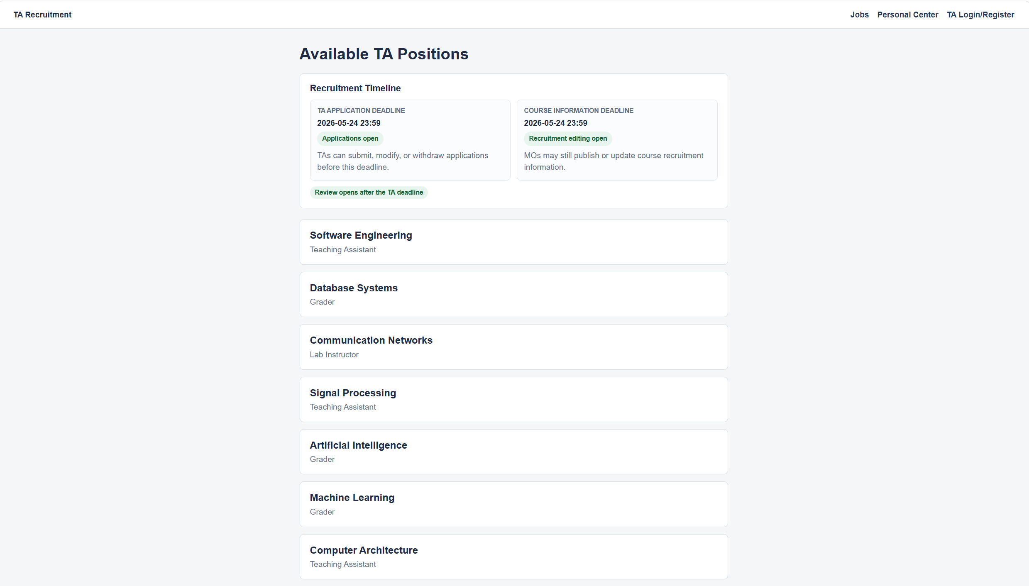
Figure 1: TA home job list
To register, click TA Login/Register, enter a BUPT email such as student001@bupt.edu.cn, submit the form, and save the generated access key, for example TA-ABCD-2345. The email must end with @bupt.edu.cn, a registered email cannot be used again, and the generated access key is the TA login credential.
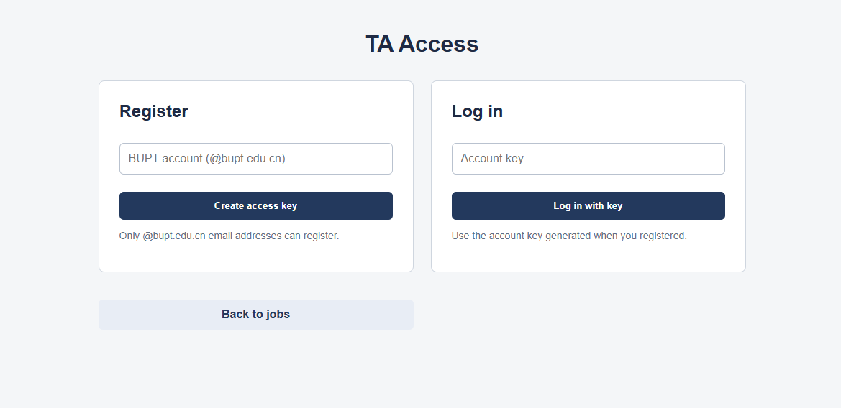
Figure 2: TA login and registration
After logging in with the access key, click Find a Job to browse published TA positions. Open a course card to view the course detail page. The detail page shows the course name, job title, job requirement, application entry, and withdraw option if the TA has already applied.
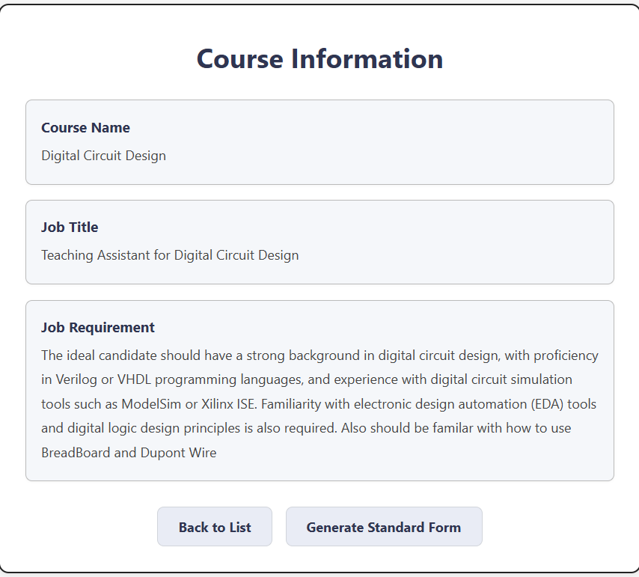
Figure 3: TA course detail
Before applying, a TA must upload a PDF resume. Open a course application page, choose a PDF file, and upload it. The uploaded file becomes the TA profile resume. If a TA already has a profile resume, the same resume is reused for applications. To replace the resume, use the Personal Centre.
To generate an application form, open a course detail page and click Generate Standard Form. The system uses the TA profile, resume text, and course information. If Groq API is configured, it generates a more detailed AI-assisted form. If AI is unavailable, fallback generation is used. Generated fields include applicant name, email, education, skills, relevant experience, project experience, and feedback.
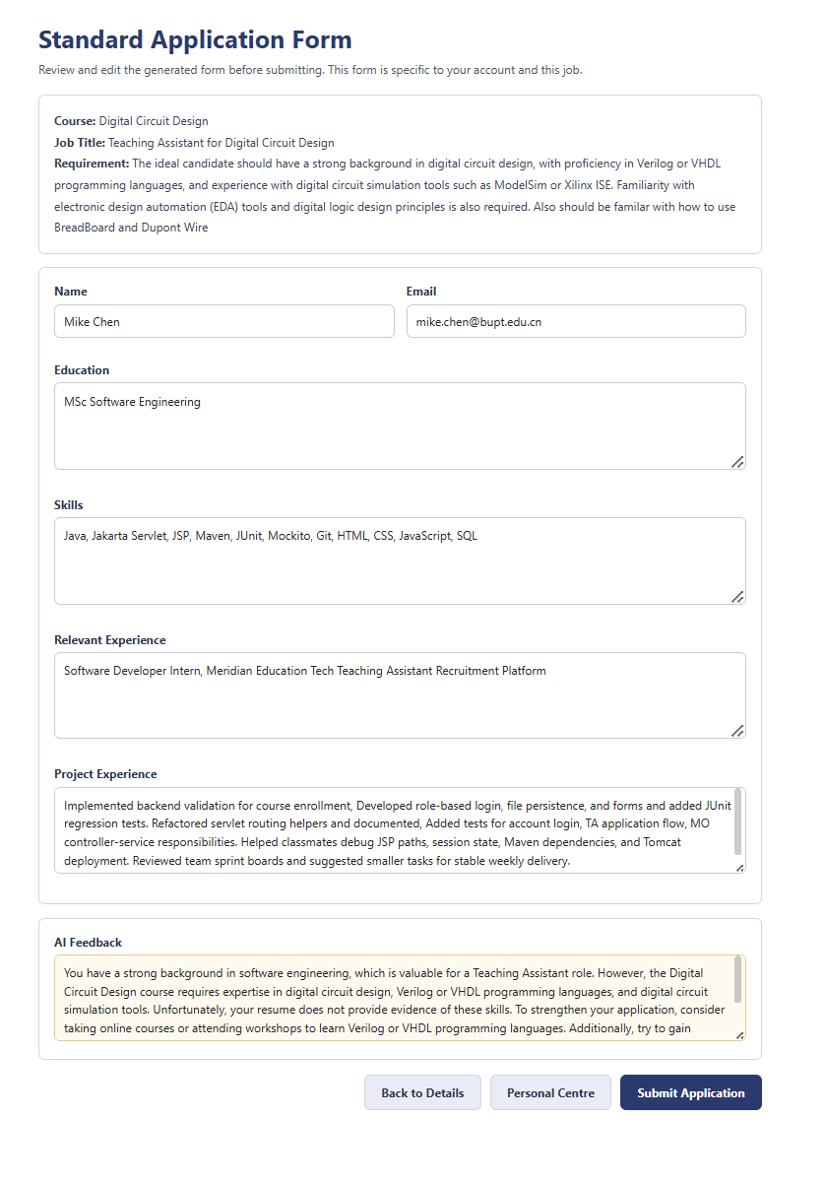
Figure 4: TA generated application form
To submit an application, review the generated form, edit fields if necessary, and click Submit Application. A TA can apply for up to 3 different positions. After the TA application deadline, new applications, modifications, and withdrawals are disabled.
Before the deadline, the TA can open Personal Centre, select an applied course, click Modify Application Form, edit the form, and submit it again. The TA can also withdraw an application from Personal Centre or the course detail page. After withdrawal, the course is removed from the TA application list.
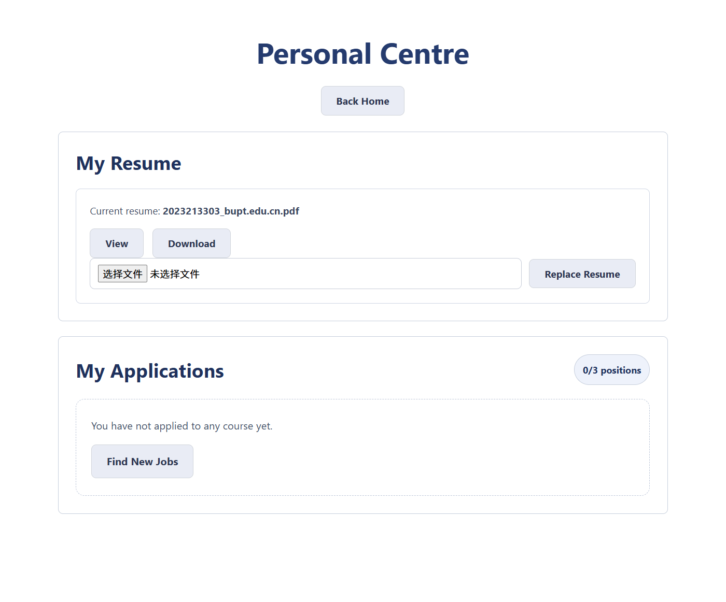
Figure 5: TA personal centre
After an MO publishes review results, the TA opens Personal Centre, selects the applied course, and checks whether the status is Pending, Approved, or Rejected. If there is a newly published result, the logged-in TA public page shows a red notification dot on Personal Center, and the updated course in Personal Centre also shows a red dot. Opening Personal Centre clears unread result notifications for that TA.
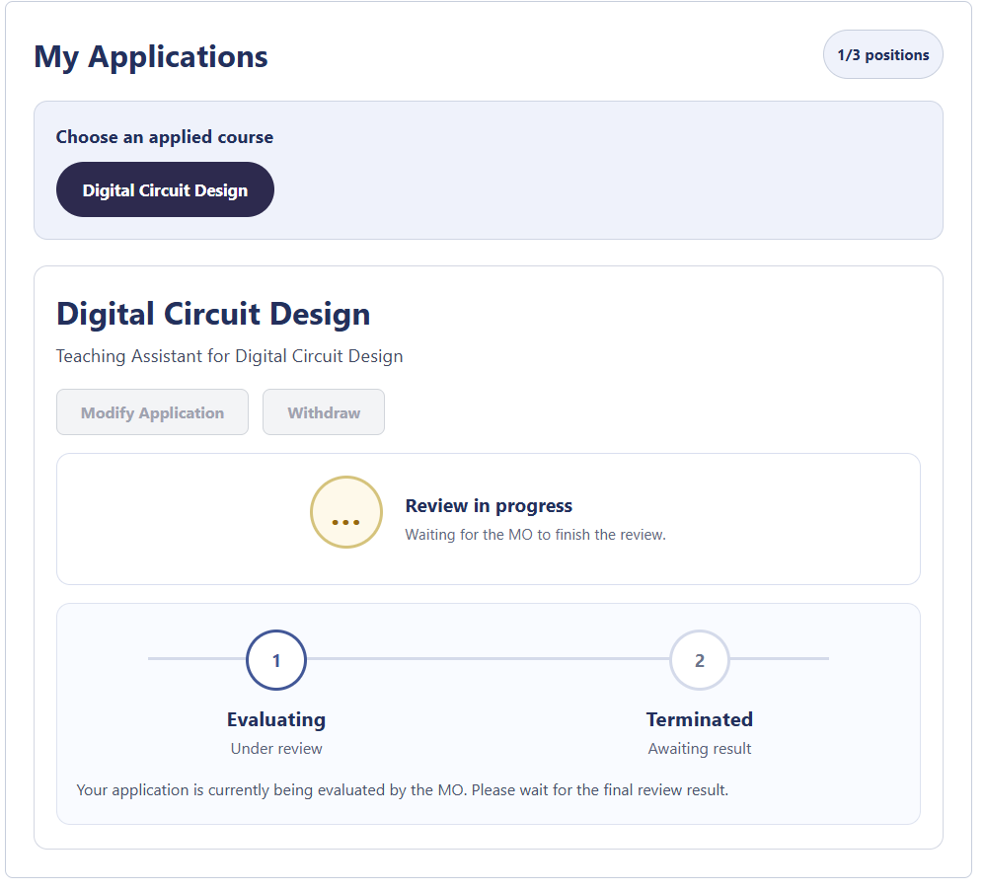
Figure 6: TA review result (before reviewed)

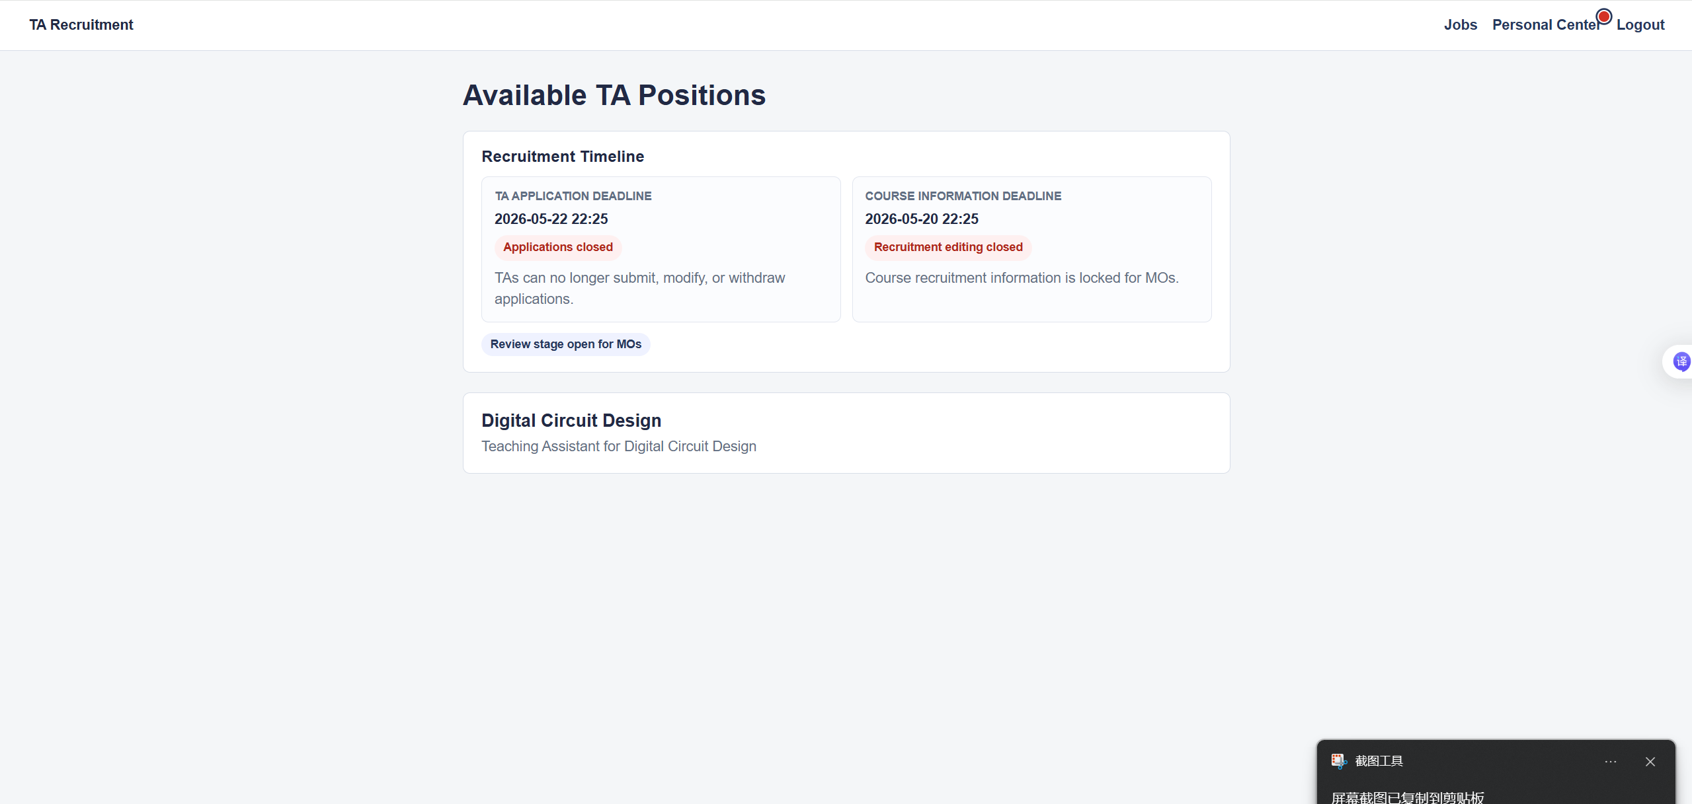
Figure7: TA dashboard (after reviewed by Mo)

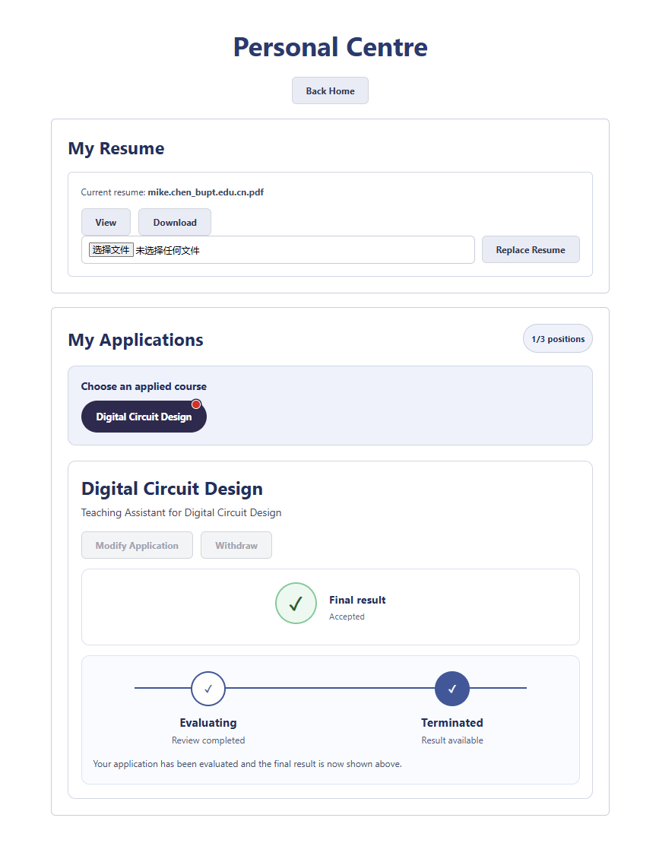
Figure8: TA review results (after results published by Mo)

7. MO User Guide
Open:
http://localhost:8081/SE/mo

Example account:
ChaoShu@bupt.edu.cn
ChaoShu123

After login, the MO Dashboard is displayed.
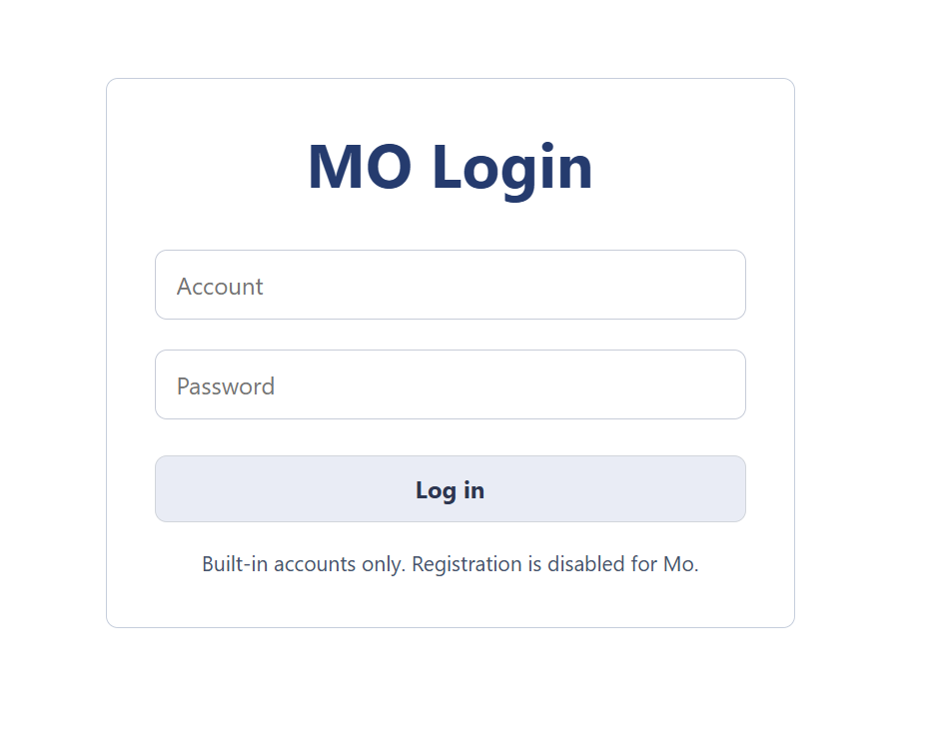
Figure 9: MO login
The MO Dashboard provides entries for recruitment publishing, personal centre, and logout. It also shows the TA application deadline, course information deadline, TA application status, MO recruitment editing status, and review stage status. If the MO course modification deadline has passed, recruitment publishing is locked and a deadline message is shown.
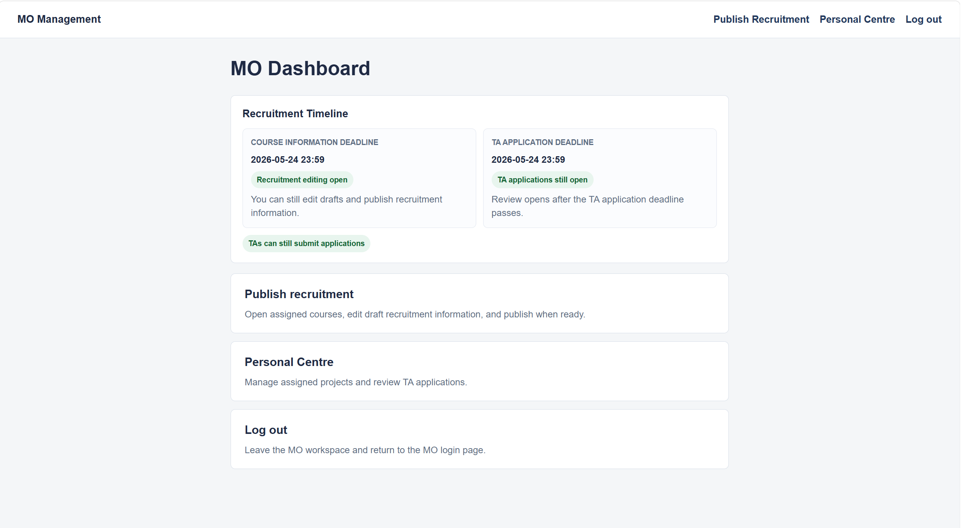
Figure 10: MO dashboard
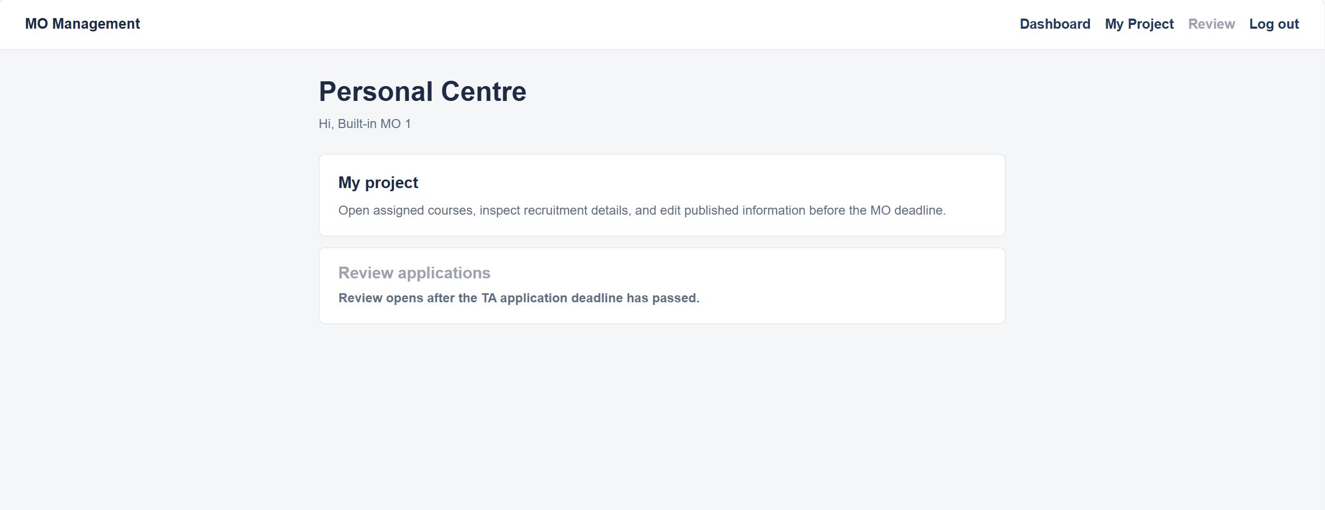
Figure 11: MO personal center
To view assigned projects, click Publish Recruitment or My Project. The system lists courses assigned to the current MO. Click a course to open Project Detail. Use Back to Personal Centre or Back to Dashboard for navigation.
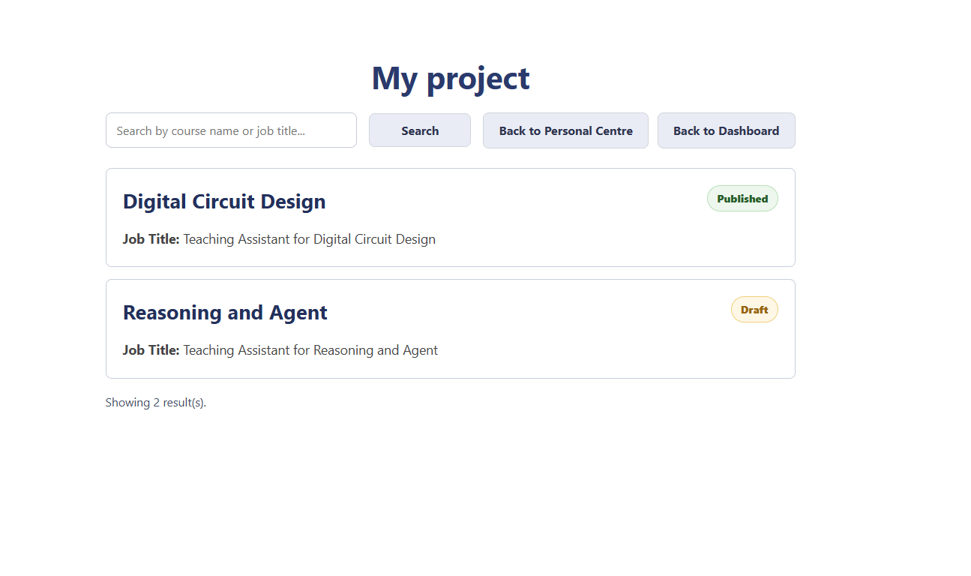
Figure 12: MO my projects
In Project Detail, the MO can edit job title, job description, and job requirement. Save draft saves changes without publishing the position to TAs, while Publish recruitment makes the position visible to TAs. Editing and publishing are disabled after the MO course modification deadline, and an MO can only manage assigned courses.
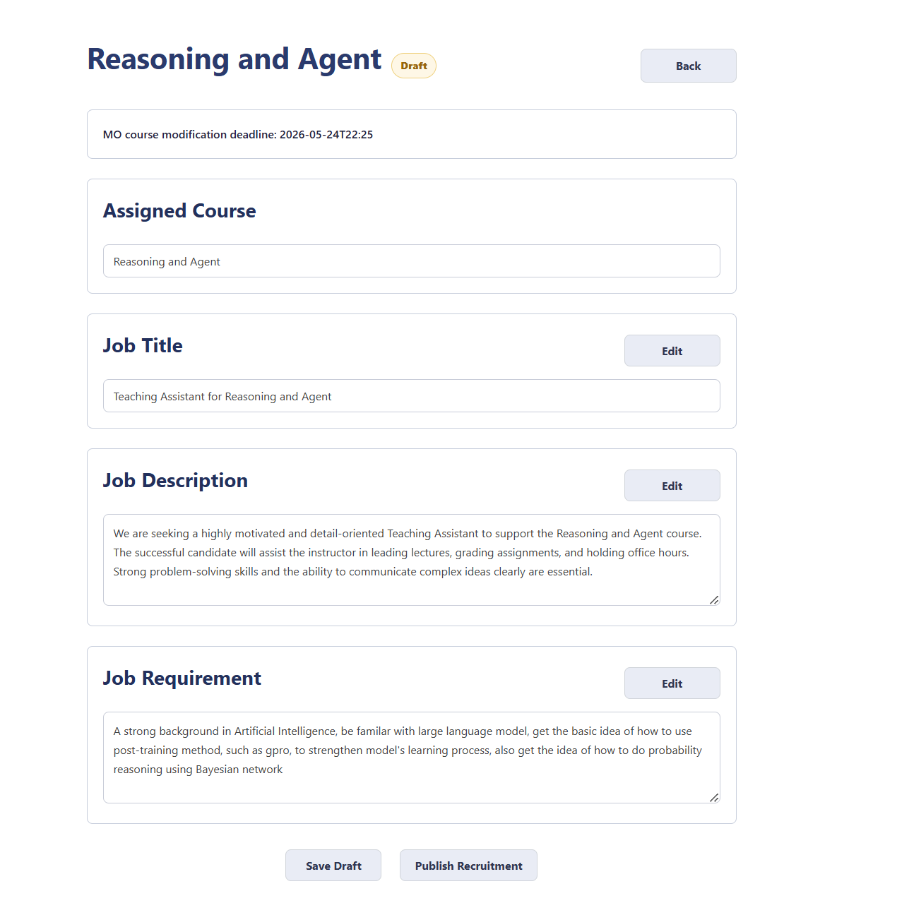
Figure 13: MO project detail(draft)

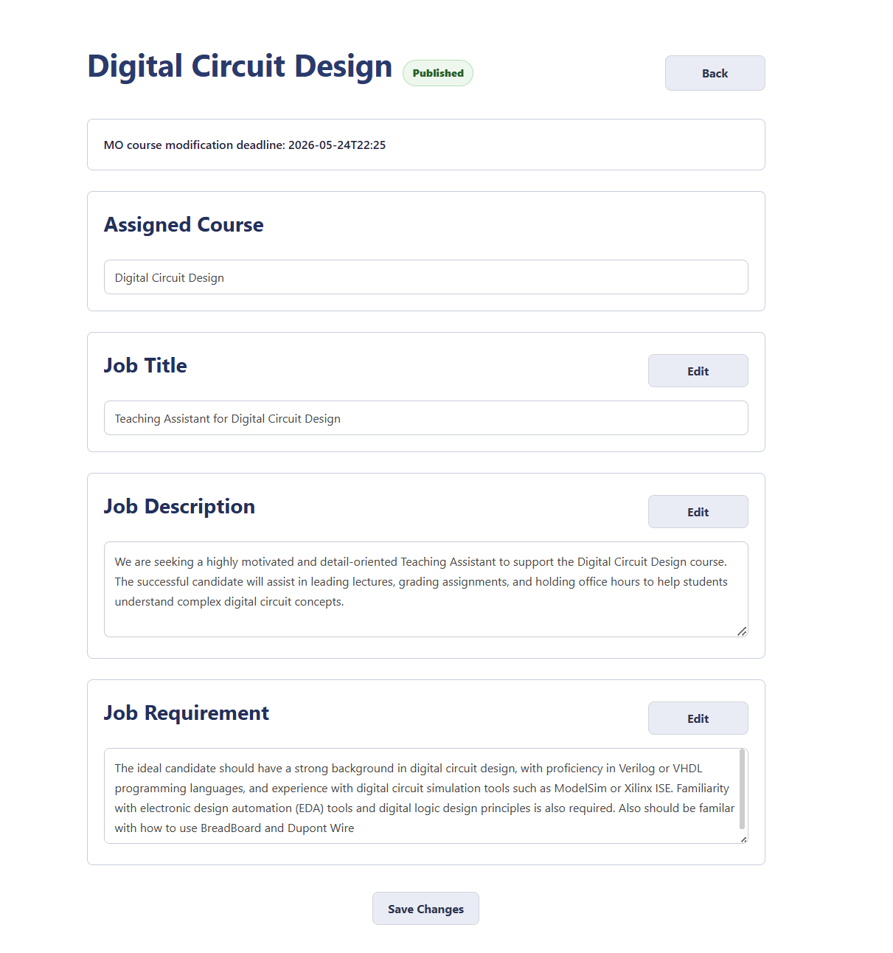
Figure14: Mo project detail(published)
Review opens after the TA application deadline has passed. The MO opens Personal Centre, clicks Review applications, chooses a course, and reviews submitted application forms. The review table shows applicant name, email, education, skills, relevant experience, project experience, and a selection checkbox.
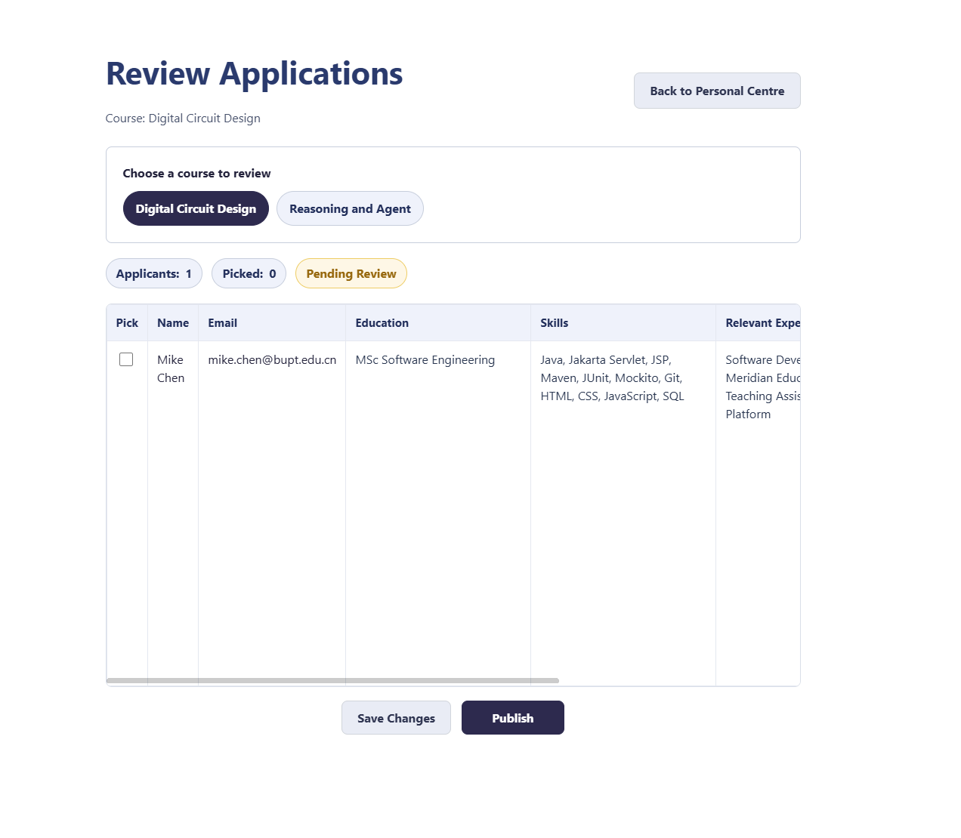
Figure 15: MO review candidates
The MO can select candidates and click Save Picks to save the selection without publishing it to TAs. For final confirmation, the MO selects accepted candidates and clicks Publish Review. Selected candidates become Approved, other submitted candidates become Rejected, TAs can view results in Personal Centre, affected TAs receive unread result notifications, and after publication the course review result cannot be edited.
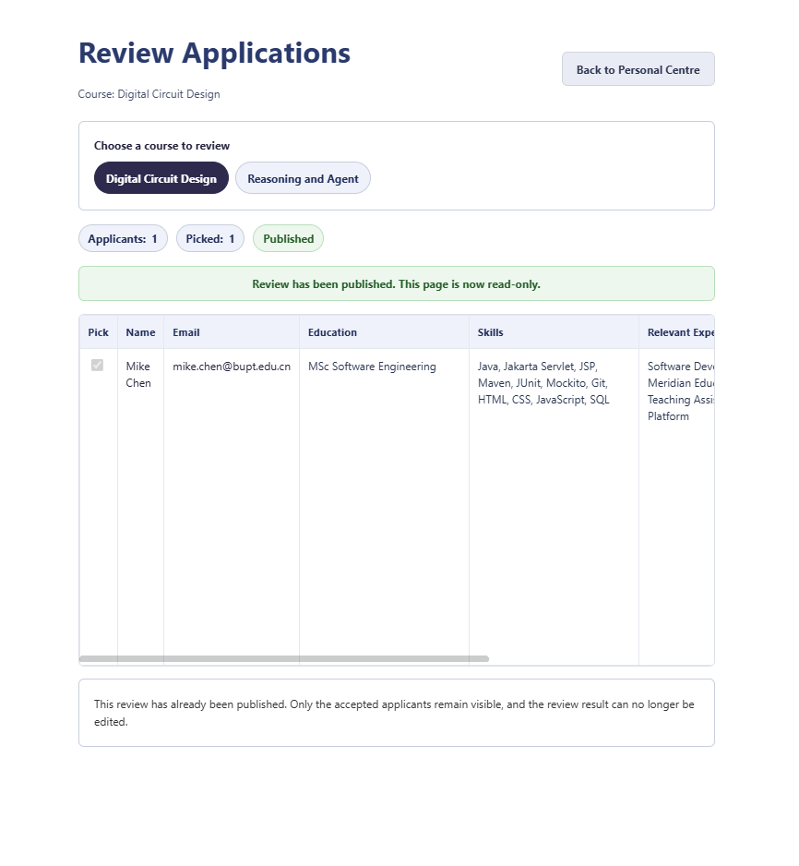
Figure 16: MO published review result

8. Admin User Guide
Open:
http://localhost:8081/SE/admin

Example account:
admin1@bupt.edu.cn
admin123456

After login, the Admin Dashboard is displayed.
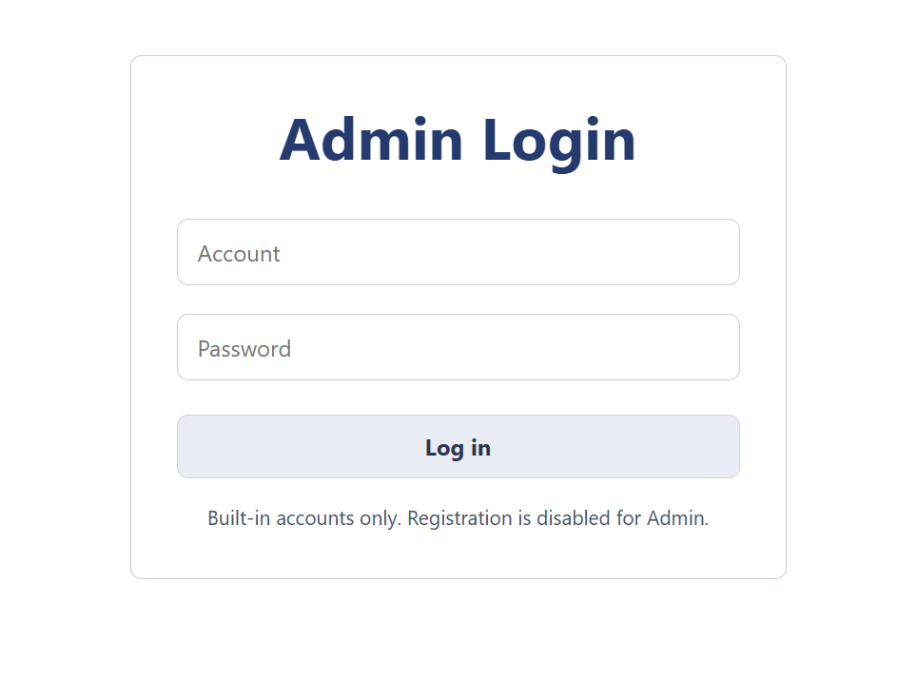
Figure 17: Admin login
The Admin Dashboard provides entries for MO accounts, candidates, TA application deadline, MO course modification deadline, reset recruitment cycle, and logout.
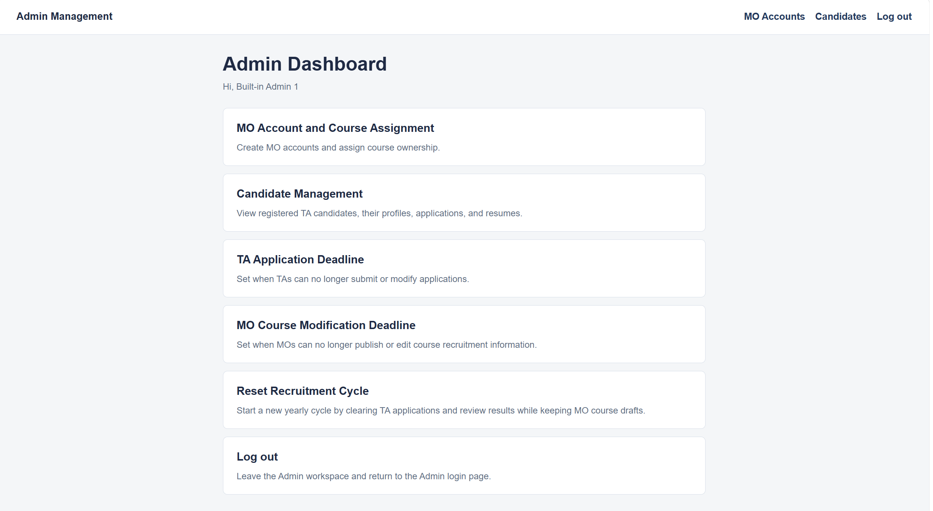
Figure 18: Admin dashboard
To create an MO account, open MO Accounts, fill in account, password, and assigned courses, enter one course name per line, and click Create MO Account. If a course already exists, it is reused. If a course does not exist, the system creates it as an unpublished course. The MO Accounts page also lists MO account, password, assigned courses, and published or draft status.
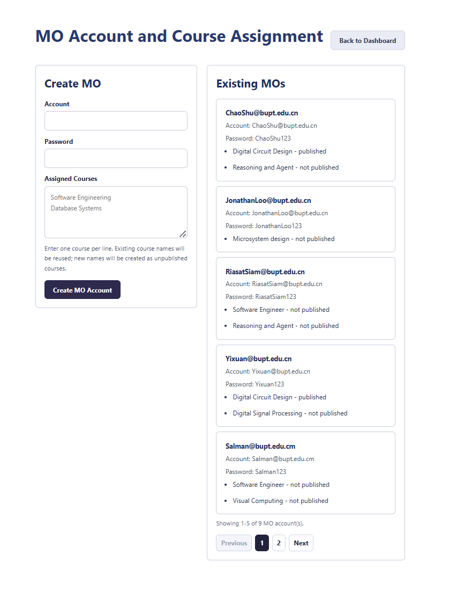
Figure 19: Admin MO management
To view candidates, open Candidates. Admin can view registered TA users, access keys, applied courses, and course information. If a resume exists, it can be opened from the candidate workflow.
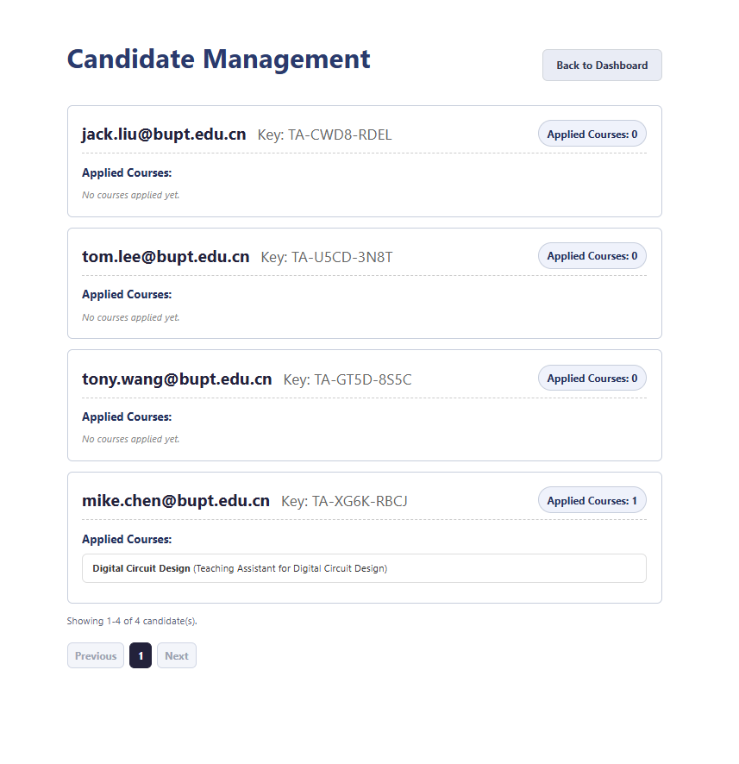
Figure 20: Admin candidate management
To set the TA application deadline, open TA Application Deadline, enter date and time, and save. Before the deadline, TAs can apply, modify, and withdraw. After the deadline, TA changes are locked and MO review opens. The value is saved to deadline.txt and stored in ServletContext as applicationDeadline. The TA public page and MO dashboard display the deadline and status.
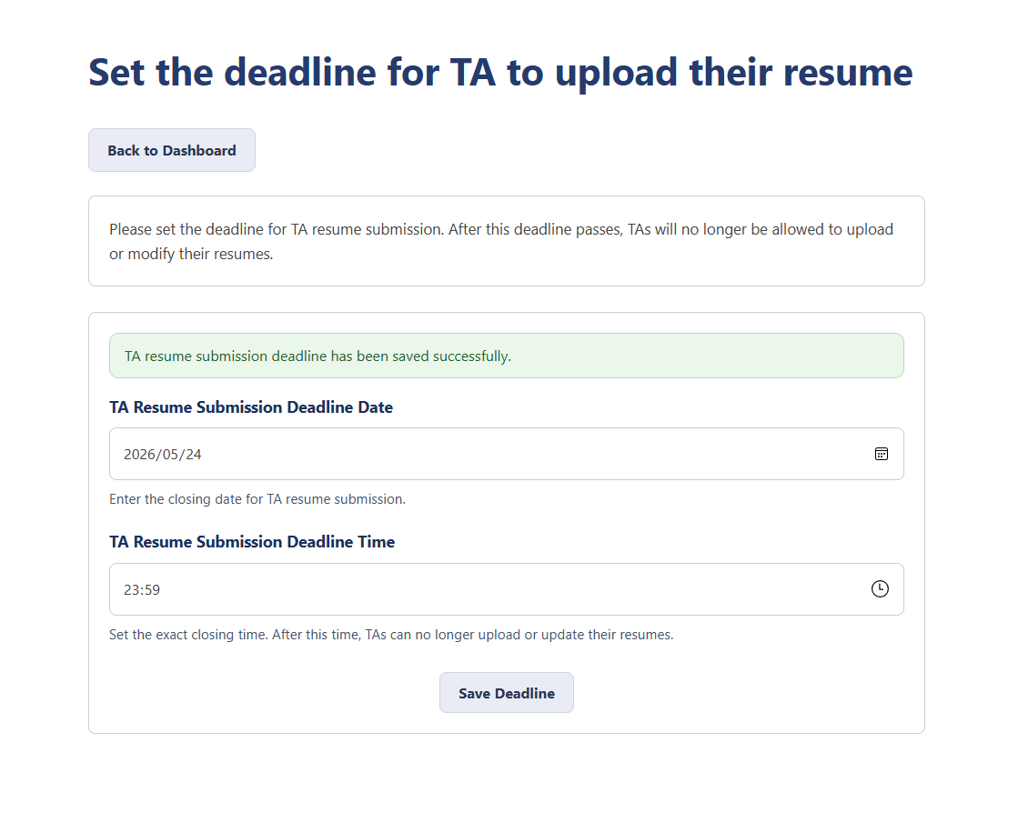
Figure 21: Admin TA application deadline
To set the MO course modification deadline, open MO Course Modification Deadline, enter date and time, and save. Before the deadline, MOs can edit and publish recruitment information. After the deadline, MO editing and publishing are locked. The value is saved to mo-deadline.txt and stored in ServletContext as moCourseModifyDeadline. The TA public page and MO dashboard display the deadline and status.
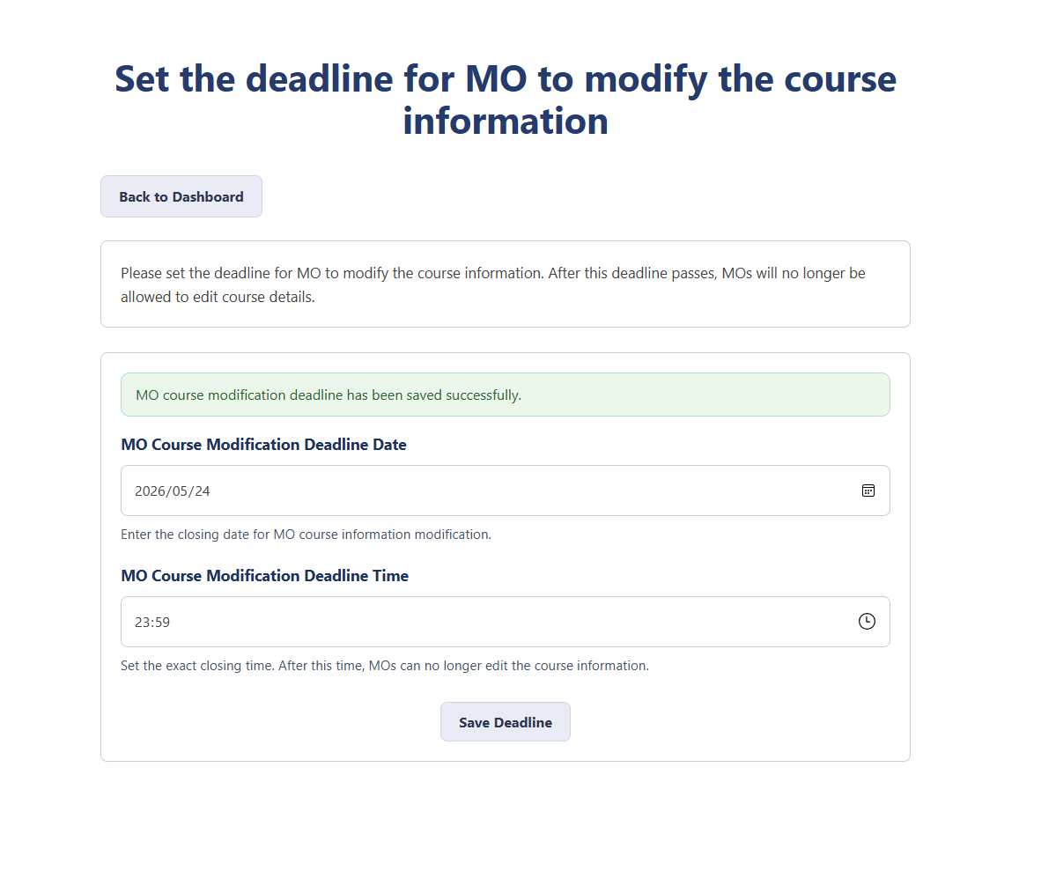
Figure 22: Admin MO course modification deadline
To reset the recruitment cycle, open Reset Recruitment Cycle from the Admin Dashboard, read the reset summary, type RESET, and click Reset Cycle. The reset keeps TA accounts, MO accounts, MO-course ownership, course names, and previous recruitment text. It clears TA applications, generated application forms, MO review picks, final review results, unread review notification dots, and both deadline values. All courses become Draft.
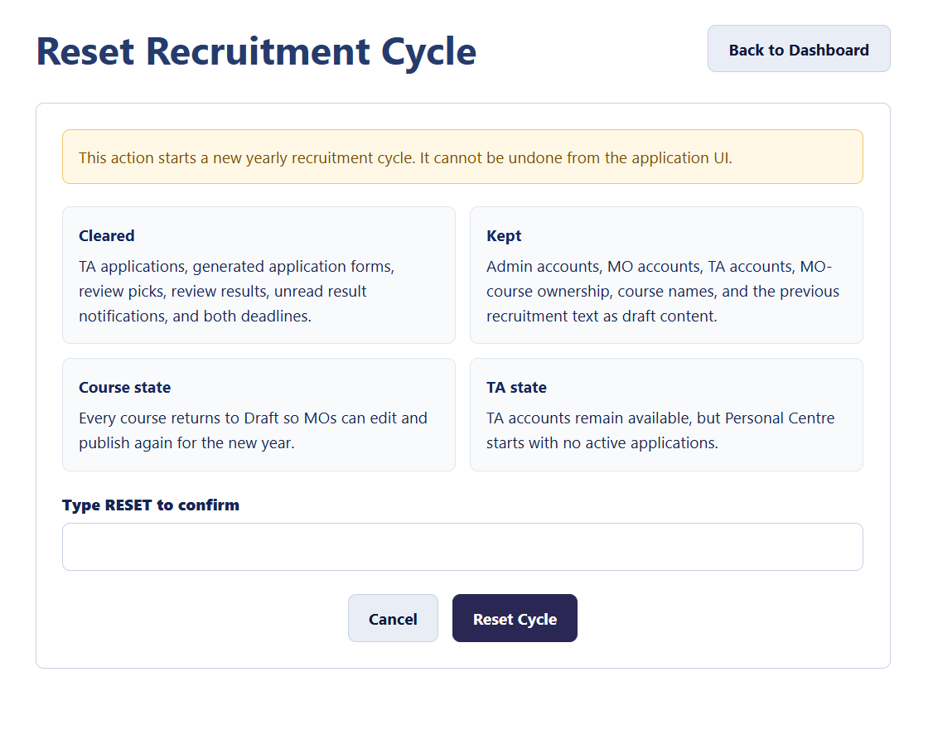
Figure 23: Admin reset recruitment cycle

9. Demonstration, Testing, and Validation
Suggested full demonstration flow:
- Run mvn test and show that tests pass.
- Run start_SE.bat.
- Open Admin entry and log in with admin1@bupt.edu.cn / admin123456.
- Set a future TA application deadline and a future MO course modification deadline.
- Set Mo accounts and assign its courses
- Open MO entry and log in with Mo account.
- Open My Project, select Software Engineering, edit job title, description, and requirement, then publish recruitment.
- Open TA entry, register a new @bupt.edu.cn email, save the generated access key, and log in as TA.
- Open Find a Job, view the published course, upload a PDF resume, generate an application form, and submit it.
- Return to Admin and set the TA application deadline to a past time.
- Return to MO Review applications, select a candidate, and publish review results.
- Return to TA Personal Centre and check the final result.
Recent validation workflow:
- Inspected project structure and Maven configuration.
- Ran mvn test and mvn clean test.
- Ran webapp\command2.bat to verify manual deployment compilation.
- Started Tomcat with start_SE.bat.
- Checked that Tomcat listens on port 8081.
- Requested /SE/ta, /SE/mo, and /SE/admin.
- Logged in as Admin and requested dashboard, MO management, candidate management, and deadline pages.
- Logged in as MO and requested dashboard, my project, personal centre, and project detail.
- Registered a temporary TA, requested TA job pages and personal centre, then cleaned temporary data.
- Checked Tomcat logs for deployment or JSP errors.
- Fixed CSV persistence corruption while preserving the architecture.
- Added regression tests for quoted CSV values in CourseStore and UserStore.
- Added deadline timeline display to the TA public page and MO dashboard.
- Kept deadline page state sourced from ServletContext and initialized it from AppContextListener.
- Added MO navigation buttons, simplified Review Applications navigation, removed the Course Fit field, restored TA review-result notification dots, and added Admin Reset Recruitment Cycle.
- Ran mvn test again and confirmed 134 tests pass.
- Ran webapp\command2.bat again and confirmed deployment compilation passes.
Useful test and run commands:
mvn test

mvn clean test

cmd /c webapp\command2.bat

start_SE.bat

./start_se.sh

Demo checklist:
- [ ] mvn test passes.
- [ ] start_SE.bat starts Tomcat.
- [ ] http://localhost:8081/SE/ta opens.
- [ ] http://localhost:8081/SE/mo opens.
- [ ] http://localhost:8081/SE/admin opens.
- [ ] Admin can log in.
- [ ] MO can log in.
- [ ] TA can register and receive an access key.
- [ ] MO can publish at least one course.
- [ ] TA can view the published course.
- [ ] TA can submit an application form.
- [ ] Admin can set deadlines.
- [ ] Admin can reset the recruitment cycle.
- [ ] TA public page shows both deadline statuses.
- [ ] MO dashboard shows both deadline statuses.
- [ ] Logged-in TA sees a red notification dot after MO publishes review results.
- [ ] Guest TA public page does not show notification dots.
- [ ] MO can review after the TA deadline.
- [ ] TA can view the final result.

10. Troubleshooting and Known Limitations
Common problems:
Problem | Possible Causes and Checks
Page cannot be opened | Check that Tomcat is running, port 8081 is used, the URL includes /SE, and TOMCAT_HOME points to the correct Tomcat folder
Login fails | Check email/password, remember that TA users log in with an access key, confirm users.txt exists, and inspect the Tomcat runtime data file instead of only the source file
TA cannot see courses | No MO has published recruitment yet, the course is still Draft, or Tomcat is using a different courses.txt file
MO cannot edit courses | The MO course modification deadline has passed, the account does not own the course, the session has expired, or Tomcat needs restart after deadline files were changed
MO cannot review applications | Review opens only after the TA application deadline has passed
TA cannot apply or modify | The TA application deadline has passed, the TA already applied for 3 positions, the uploaded resume is not a PDF, the session has expired, or Tomcat needs restart after deadline files were changed
AI generation does not work | Check GROQ_API_KEY, restart Tomcat after setting it, verify the key is valid, check network access to Groq API, and remember fallback generation still works
TA does not see a review notification dot | The TA must be logged in, MO must publish final results rather than only save picks, the TA must not have already opened Personal Centre after publication, and /SE/ta may need refresh

This is a coursework prototype rather than a production system. Known limitations:
- Passwords are stored in text files. A real system should hash passwords.
- Some JSP pages still directly output values. A real system should apply consistent HTML escaping.
- Runtime paths assume the deployed context is /SE.
- Groq API transport currently depends on Windows PowerShell.
- File-based persistence has limited concurrency protection.
These limitations do not block the current coursework demo, but they should be prioritized in future development.

